**SOP4 2022**

**CP&A – REQUIREMENTS & INSTRUCTIONS**

Key Messages 3

Assumptions and key points 4

Additional input forms 5

Appendix 5

Tax Reconciliation 5

Associates 6

Minorities 8

Required Reviews 9

Intercompany for BPC MGMT 9

Internal Accounts above Profit from Operations 9

Internal Accounts below Profit from Operations 10

Balance Sheet Accounts 10

Inter-company matching report 10

Thresholds & rules 11

Summary of BPC MGMT Accounts relevant for intercompany process 12

Master Data Changes 13

CAPEX WBS changes for IFRS 16 13

MGMT Accounts – IFRS16 13

# Key Messages

**Guidance: SOP2, SOP3, SOP4 2021**

* The table below summarises the Financials requested to be reported bottom-up during the following SOP cycles
* Regions/DRBUs/EMs are welcome to use discretion and report in greater granularity if they wish – the items below are the requested “*minimum*”

|  |  |  |  |  |  |
| --- | --- | --- | --- | --- | --- |
| **Topic** | **SOP2 Approach** | **SOP3 Approach** | **SOP4 Approach** | **Comments** | |
| CY P&L to APFO | Y | Y | Y | **Reflecting the appropriate product category split.** | |
| CY P&L below APFO | N | N | Y | In SOP2/3 Adjusting items continue to be estimated Centrally, to feed into Cash Flow estimates – see below | |
| CY Operating Cash Flow | Y | Y | Y | Monthly update continues to be required. | |
| CY Cash below OCF and BS | N | N | Y | Below OCF items not required to be reviewed for SOP2 & SOP3.  A full balance sheet and cash flow is required at SOP4. | |
| ***CY+1 FX Rate:******GBP_ACT_20*** *for SOP02 & SOP03;* ***M04 Rate*** *for SOP4 onwards (YoY growth)* | | | | | |
| CY+1 P&L to APFO | Y | Y | Y | Focus on Volume/NTO/GM. Recommended to copy-across MI/Overheads and adjust as necessary. **Reflecting the appropriate product category split.** | |
| CY+1 P&L below APFO | N | N | N | Required at SOP10 | |
| CY+1 Operating Cash Flow | N | N | N | Required at SOP10 | |
| CY+1 Cash below OCF and BS | N | N | N | Required at SOP10 | |
|  |  |  |  |  | |
| H1 CY P&L to APFO | Y | Y | Y |  | |
| H1 CY P&L below APFO | N | N | Y |  | |
| H1 CY Operating Cash Flow | N | N | Y |  | |
| H1 CY Cash below OCF and BS | N | N | Y |  | |
|  |  |  |  |  | |
| ***Supplementary schedules:*** |  |  |  |  | |
| Competition Reporting | N | Y | N | PY Actuals and CY Forecast | |
| Cost of Sales | N | N | Y | Applicable for CY and CY+1 (CY+1 Regional input only) | |
| Capex | N | N | Y | Applicable for CY and CY+1 | |
| Pricing Tracker | Y | Y | Y | CY high-level changes for SOP2/SOP3. Detailed Tracker in SOP4 for CY and CY+1 | |
| NCL | N | Y | N | PY Actuals and CY Forecast | |
|  |  |  |  |  | |
| Channel and MI Reporting per new WBS structure for NC | Y | Y | Y | Applicable for CY and CY+1 |

## Assumptions and key points

* **Exchange rates**
* CY will continue to be reported at GBP_ACT_20.
* CY+1 FX Rate: **GBP_ACT_20** for SOP02 & SOP03; **M04 Rate** for SOP4 onwards.
* **Interest rates** - The interest rates will be communicated to the EMs directly by Mehul Ramji.
* **Adjusting Items –** For SOP4 CY, the current adjusting items policy applies. The policy, guidance and example of costs and treatment on adjusting items can be found on interact:

<http://interactbat.z2.batgen.com/interact/finance/sb_finance.nsf/(0)/3497D3191F6EA568C125827A00317AA2XXX?opendocument>

If you have any further questions, please liaise with GSRT Team: Laurence Gallé/ Alina Negrea

* **Group Recharge –** all group recharges files have been saved to the new [SharePoint location](https://bat.sharepoint.com/sites/CommercialPlanningAndAnalysis/SitePages/Group-Recharges.aspx):
  + - 1. **ITD –** Laura Ursu
      2. **T&A –** Elena Harcel & Valentin Delcea
      3. **Share Scheme –** Oana Dima & Roxana Stere
      4. **GBS –** Ana-Maria Antonache (ENA); Poorni Ramamoorthy (APME); Arturo Alfaro (AMSSA)

## Additional input forms

On the top of the main financial statements additional input forms are available and required to be completed at every actual reporting cycle.

Additional input forms are required to be completed by all entities for as per below table:

|  |  |  |  |
| --- | --- | --- | --- |
| **Additional input forms** | **Related to:** | **Guidelines:** | **SOP4**  (CY & CY+1) |
| Tax Reconciliation (1st tab) | Financials | Please see below the guidelines | Yes (CY only) |
| Tax Rec: Tax on adjusting items (2nd tab) | Financials | Please see below the guidelines | Yes (CY only) |
| Associates | Financials | Please see below the guidelines | Yes (CY only) |
| QBS | Financials | Please see below the guidelines | Yes (CY only) |
| CAPEX by function | Financials | Please see below the guidelines | Yes |
| Flow Reclassification and Additional Inputs for CF | Financials | Please see I301 input form | Yes (CY only) |

# Appendix

## Tax Reconciliation

A reconciliation of the “REPORTED TAX” (Corporate + Deferred + WHT) movements from Nominal (statutory) to Effective tax rates is required. The input form I106 (as below) is available to assist P&R teams with this reconciliation.

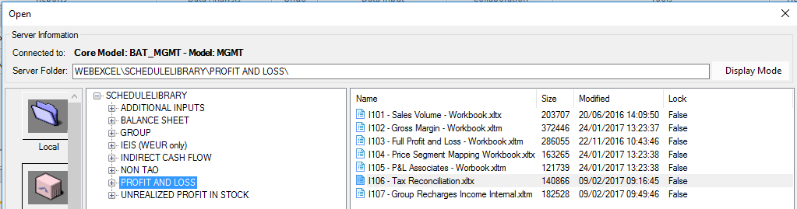

End markets have the option to perform a single submission by company code or multiple ones by individual Profit Centres. If the first option is more suitable, then the below needs to be taken into consideration:

* The Profit Centre “MAIN” under which the entire company will be reported under, needs to receive a **manual** posting of “+ Profit” (Account MEMO_TAX_OBA49010).
* The other Profit Centres under the same company code need to be populated with a **manual** posting “- Profit” and therefore they will have nothing to report.
* However, for this to work properly all the taxes, whether corporate, deferred or WHT should be reported under the “MAIN” Profit centre under which the reconciliation will also be reported.

The input form is made up of 2 Tabs

* **Tax Reconciliation:** required on a full year basis. In this tab the dividends received from subsidiaries will be removed automatically as from UK perspective they are not deemed to be taxable.
* The column “YTD Adjustments posted” gives the user the visibility of the data in the database as in the input column, **some excel formulas hide the true figures in the database**.
* **To ensure the data is correct, both columns should present the same numbers.** If it happens not to be the same, most likely an adjustment has been made in the P&L and this input form hasn’t been revised. As a remediation, the data needs to be saved once again and if any validations and/or the effective TAX rate is not the desired one, the data entry will need to be revised to update in the system. **“Clearing the validation, for the sake of clearing the validation does invalidate the purpose of this data request.”** If you have any questions, please contact the Tax specialist in your EM
* A TAX REPORT is available in the input form, where data can be retrieved on a higher level than a standalone profit centre. If data is retrieved by Company Code the line Internal Profit/(loss) transfer needs to equate to ZERO, otherwise the submission is not correct.

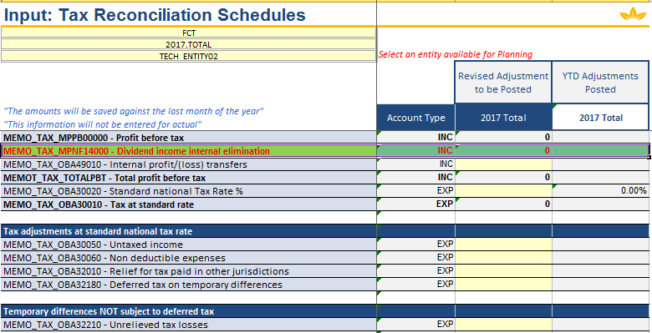

* **Tax on adjusting items.** This was provided off-line by the Tax manager and it is now required in BPC. If a market has any adjusting income/costs reported in the P&L, then the tax related to such items needs to be provided in this form. By way of example, if the adjusting items are expenses which are tax deductible, the tax on those items should be a credit and would be entered as a negative. If no tax in connection with these events is meant to be reported, then a number 1 needs to be keyed on a monthly basis on the account line **MEMO_MPTX10000_NO_ADJ.**

## Associates

Please note that Associates have their own set of accounts.

In addition, please note there are different data requirements in respect of Associates for MGMT and STAT. BPC MGMT only requires data in respect to the P&L, whereas BPC STAT also requires some BS lines to be provided.

**Input**

* Input should be on a 100% basis of the financials
* Input form can be found as follows

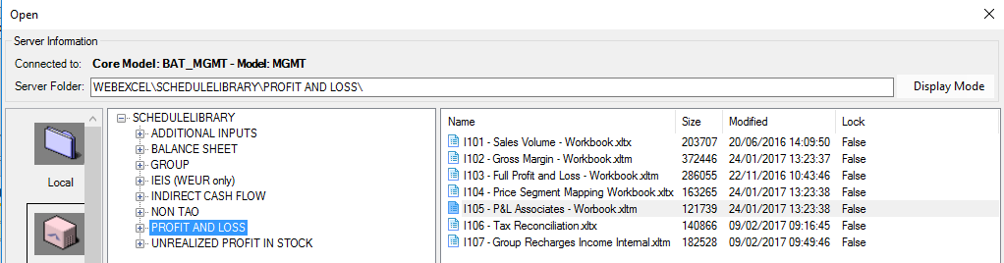

* There is unique PC for each of the Associates companies as can be observed in the print screen below and the input form has 2 tabs: one for Actual data and another one for Forecast data.

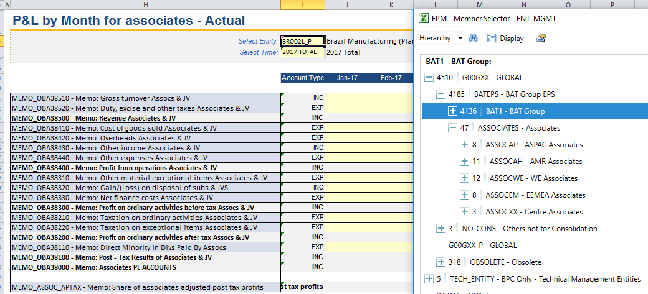

**Associates shareholding data (%)**

* If there are any changes to Associates % please liaise with Group Statutory Reporting Team – GSR at BAT_Group_Accounts@bat.com as well as informing Regional Finance Controller.
* Ownership % is maintained in BPC STAT and is the driver for MEMO account (**MPAS00000)** Share of post-tax results of associates and joint ventures.

**MPAS00000 - Share of post-tax results of associates and joint ventures**

* Calculated automatically (after “Calculate all” package has been performed/at Submission) based on :
  + MEMO_ASSOC_APTAX (the base) and
  + STAT ownership % database
* Formula **= MEMO_ASSOC_APTAX * STAT Ownership%**

**MPAS10000 - Share of post-tax results of associates and JV (adjusting)**

* Needs to be calculated and input manually based on:
  + **Associates’ adjusting items as per MEMO accounts** (the base) and
  + **STAT ownership % database** (=MEMO_POWN- Financial interest rate)
* Formula **= *Associates’ adjusting items as per MEMO accounts*** **\* STAT Ownership%**

***Associates’ adjusting items as per MEMO accounts*:**

**MEMO_OBA38320 - Memo: Gain/(Loss) on disposal of subs & JVS            (Income acc)**

**less      MEMO_OBA38310- Memo: Other material exceptional items Associates & JV    (Expense acc)**

**less      MEMO_OBA38220- Memo: Taxation on exceptional items Associates & JV       (Expense acc)**

**Submission and Approval of Associates**

* As any other entity, Associates need to be submitted and approved
* Regional team will need to override the following management validations: #1 “Retained Earnings vs. Movement in Equity account MBEQ14100” and #2 “Balance Sheet Balancing” as for Associates, Balance Sheet and Cash Flow are not required in BPC MGMT (as above).
* Due to a distinct place in the entity hierarchy structure, Associates are not part of the regional view. The regional teams need to ensure they have access to the relevant top level Associates nodes.

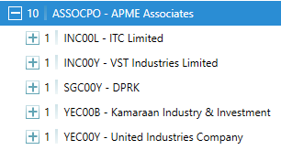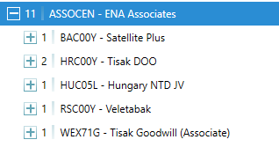

***Notes:***

* **MEMO_ASSOC_APTAX** *( The base) - to be checked before EMs approval*
* NO *Manual inputs are allowed into* **MEMO_ASSOC_APTAX** as it is a calculated account.
* *% Ownership to be checked by EMs*

## Minorities

Please note in BPC MGMT the minorities value is stored under MEMO account: MEMO_NCI_PAT. BPC MGMT calculates the minorities automatically based on the ownership % maintained in BPC STAT.

**Minorities shareholding data (%)**

* If there are any changes to minorities % please liaise with Group Statutory Reporting Team - GSRT at BAT_Group_Accounts@bat.com as well as informing Regional Finance Controller.
* Ownership % is maintained in BPC STAT and is the driver for MEMO account (**MEMO_NCI_PAT)** in BPC MGMT.

**MEMO_NCI_PAT - Non-Controlling Interest Share of Profit After Tax**

* Calculated automatically (after “HANA Calculate all” package has been performed/at Submission) based on STAT ownership % database as above;
* **Formula** (**MEMO_NCI_PAT)** = (PAT-DIV incl.)*(1-STAT Ownership %)

***Notes:***

* ***% Ownership*** *to be checked by EMs*
* ***MEMO_NCI_PAT*** *to be checked before EMs approval;*

## 

## Required Reviews

As highlighted previously, please note that all entities are required to look into the below checks as part of their submission in terms of data accuracy and integrity.

|  |  |  |
| --- | --- | --- |
| Review: | **Applicable** | |
| Q1 | SOP04 |
| *FI/COPA mismatches* | Yes | Yes |
| *Full Set of Financials* | No (P&L up to APFO, B/S optional) | Yes |
| *Adjusting Items* | No | Yes |
| *Net Finance Costs and Tax* | No | Yes |
| *Minorities (See section 2.2 )* | Yes | Yes |
| *Associates (See section 2.2)* | No | Yes |
| *STAT vs MGMT Reconciliation* | Yes | n/a |

In accordance with the Global Journal Policy, DQI corrections below £20K at an individual P&L line level are not permitted, unless requested by CP&A team for the Group consolidation purposes.

# 

# Intercompany for BPC MGMT

## Internal Accounts above Profit from Operations

* **Intercompany Actuals**

Total Q1 and SOP04 intercompany reports will have to consider YTD Jan-March 2021 Actuals.

Please see below the steps that need to be followed to clear actual intercompany mismatches:

* Run the validation report 904 – Internal Accounts without Partner Entity to identify any internal accounts with missing partner profit centres

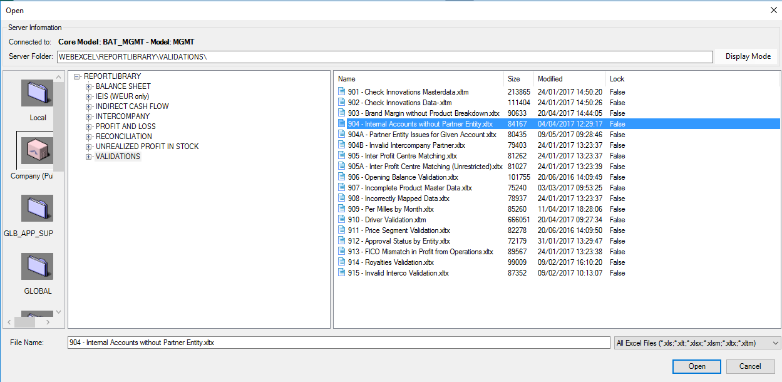

* To clear the missing partner profit centre, P&R team needs to raise a journal to IGT team so that missing profit centre is corrected. You can populate the missing partner profit centre with the default partner profit centre of the trading partner or with the correct one (new functionality has been introduced in ECC to allow users to specify the partner profit centre in a journal).
* If the correct partner profit centre is to be used, P&R team needs to raise a journal to IGT team so that incorrect profit centre is corrected.
* Once all missing partner profit centre have been corrected please run the ***intercompany report*** for Actual Category.

As a rule, internal accounts (both from P&L and BS perspective) have been updated to ensure that no posting is done under I_NONE in the forecast periods (this validation is also applicable for Non TaO inputs for Actuals).

## Internal Accounts below Profit from Operations

For actuals, accounts below Profit from Operations are loaded from the ECC FI module into BPC MGMT.

The accounts are grouped in the internal net finance cost matching account and are stated in the section 3.7 Summary of BPC MGMT Accounts relevant for intercompany process.

***Note: The clearing of the actual mismatches on these accounts should follow the same process as described above.***

## Balance Sheet Accounts

**It is worth mentioning that some accounts in the Balance Sheet, due to nature of their transactions do cater for both EXTERNAL as well as INTERNAL transactions (as below) and therefore if a posting refers to an internal transaction please make sure PPC is disclosed accordingly.**

MBNA12000 - Computer software

MBNA13000 - Trademarks and licenses

MBNA21000 - Property, plant and equipment

MBNA31000 - Investments in subsidiaries

MBEQ11000 - Share capital and share premium

MBEQ14900 - Other movements

MBEQ15000 - Other movements internal

Mentioned accounts, when are used with below BPC flows, require a correct PPC:

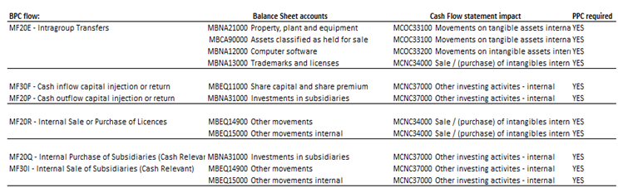

## 

## Inter-company matching report

This report is intended for EMs/GBS /Regional/Global User to run on their assigned entities.

The report will show the entities Assets/Counterparty Liabilities, Liabilities/Counterparty Assets for the BS Accounts and the Income/Counterparty Expenses, Expense/Counterparty Income for the P&L Accounts.

The above-mentioned report is available in a specific server folder:  
*(ie. Open/Server Report/Intercompany folder) and will be available to users to run.*

The Intercompany Report uses the data generated by the ***Generate PC Matching*** logic which is scheduled to run **every 4 hours for Actual** (CM-1 and CM) and skipping the 02:00 AM midnight run**.**

This logic will look for any intercompany transactions posted against an entity and update memo accounts within that entity with the numbers.

The MAVG rate will be used for matching of P&L Accounts and the Closing Rates will be used for matching of BS Accounts.

A short guidance on how to run and identify the amounts from the Report in ECC is presented in the below attached excel file:



## Thresholds & rules

Below are the rules applicable for Intercompany:

* Each EM’s/BASS/Region, as a matter of routine, **should review** the inter-company report to identify any mismatches.
* An exemption is granted, when the mismatch is generated by different profit centres, but these are in the same Market and are offsetting each other.

*(Example: UAC00L – CBU, UAO02L – OBU, both are in the same Market – Ukraine):*



* The Intercompany Reports **allow users** to run the reports on demand and for their assigned entities without having access to the counterparty’s numbers
* **Balance sheet** accounts (**Loans & Borrowings, Debtors/Creditors** **and Interest Payable/Receivable**) the threshold by Market view and Management account is **£50k**.
* **Internal Interest (P&L)**, transactions with BATIF will be matched by BATIF; other internal transactions need to be correct (variances of up to £50k per entity are acceptable).
* **Internal Cash flow**: dividends controlled by the Netherlands and BAT Holdings will need to be matched as before. For other internal transactions as dividends, CAPEX and interest variances up to £50k per entity/line are acceptable. For any other transactions within internal Cash flow we would not expect any variances.
* The Cash Flow rules for **WHT paid on Interest and Dividends** form part of Cash Generated from Operations and Net Cashflow respectively. These Cash Flow rules are not generated based on ECC transactions only, but also based on WHT manual input (**MEMO_OBA60200 - WHT for internal interest, MEMO_OBA60300 - Withholding tax for internal dividends**) which means that for a correct elimination of **Internal Cash Flow** these inputs must be agreed with counterparts and done correctly.
* Unless specified otherwise above **all inter-company differences above £50K** should be investigated and cleared between the counter-parties before the closure of Q exercise.
* All inter-company balances **should be agreed** in advance.
* The following **Global intercompany principles apply** to the P&L accounts below:
* Group recharges – income drives
* Royalties – expense drives
* Other income and expenses – income drives

## Summary of BPC MGMT Accounts relevant for intercompany process

In summary, these are the accounts relevant for the Intercompany Process and the 501 intercompany matching report

|  |  |
| --- | --- |
| **FS** | **Accounts** |
| P&L | IPCMPCO32050CL - IPC - Royalties internal expense/(income) |
| P&L | IPCMPOH21000CL - IPC - T&A fees expense/(income) |
| P&L | IPCMPOH31000CL - IPC - Share scheme expense/(income) |
| P&L | IPCMPOH32000CL - IPC - Shared services IT expense/(income) |
| P&L | IPCMPOH33000CL - IPC - TaO SAP user fee expense/(income) |
| P&L | IPCMPOH34000CL - IPC - Shared services finance expense/(income) |
| P&L | IPCMPOH35000CL - IPC - Shared services HR expense/(income) |
| P&L | IPCMPAI17000 - IPC – EOM Projects adjusting items expense/(income) |
| P&L | IPCMPOT10000 - IPC - Other operating expense/(income) |
| P&L | IPCMPNF52000 - IPC - Internal net finance costs |
| P&L | IPCMPNF14000CL - IPC - Dividends |
|  |  |
| BS | IPCMBCL12100CL - IPC - Loans and borrowings (curr) |
| BS | IPCMBCL12200CL - IPC - Borrowings (curr) - other cash pooling internal |
| BS | IPCMBCL12300CL - IPC - Loans and borrowings IHC (curr) |
| BS | IPCMBCL15200CL - IPC - Interest payable and receivable (curr) |
| BS | IPCMBCL61200CL - IPC - Trade payable and receivable (curr) |
| BS | IPCMBCL61320CL - IPC - Facility commitment fees (curr) |
| BS | IPCMBCL63300CL - IPC - Payable and receivable IHC setlmts (curr) |
| BS | IPCMBCL64330CL - IPC - Dividends payable and receivable (curr) |
| BS | IPCMBCL64410CL - IPC - Accrued income and charges (curr) |
| BS | IPCMBCL64920CL - IPC - Facility guarantee fees (curr) |
| BS | IPCMBCL74121CL - IPC - Derivative fin instrs (curr) - principal |
| BS | IPCMBCL74122CL - IPC - Derivative fin instrs (curr) - interest |
| BS | IPCMBCL74220CL - IPC - Derivative non-financial instrs (curr) |
| BS | IPCMBEQ14820CL - IPC - Ordinary dividends paid - internal |
| BS | IPCMBNL12000CL - IPC - Loans and Borrowings (non-curr) |
| BS | IPCMBNL61200CL - IPC - Trade payable and receivable (non-curr) |
| BS | IPCMBNL74200CL - IPC - Derivative financial instrs (non-curr) |
| BS | IPCMBNL74400CL - IPC - Derivative non-fin instrs (non-curr) |
|  |  |
| CF | IPCMCGO11200CL - IPC - Net interest paid internal |
| CF | IPCMCNC12000CL - IPC - Internal dividends (paid) / received |
| CF | IPCMCNC34000CL - IPC - Sale / (purchase) of intangibles internal |
| CF | IPCMCNC37000CL - IPC - Other investing activities - internal |
| CF | IPCMCOC22000CL - IPC - (Inc) / Dec in working capital Internal |
| CF | IPCMCOC33100CL - IPC - Movements on tangible assets internal |
| CF | IPCMCOC33200CL - IPC - Movements on intangible assets internal |

Internal Accounts below Profit from Operations

|  |  |
| --- | --- |
| FS | IPCMPNF52000 – IPC – Internal net finance cost |
| PL | MPFC51000 - Interest paid internal |
| PL | MPFC52000 - Preference dividends amortisation internal |
| PL | MPFC53000 - Loan impairments internal |
| PL | MPFI51000 - Interest received internal |
| PL | MPFI52000 - Borrowing impairments internal |

# Master Data Changes

## CAPEX WBS changes for IFRS 16

CAPEX WBS subfunctions have been updated in ECC to accommodate the split between Leased Asset vs Owned Asset (or genuine) as per IFRS16 requirements.

The Sub-Function is part of Capex WBS element naming convention which provides Capex breakdown.

**4 new Sub-Functions** are available (see below) and are designed for new Capex WBS elements related to **Leased Assets (IFRS16)**

[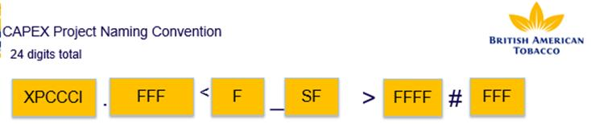](https://eu-prod.asyncgw.teams.microsoft.com/v1/objects/0-weu-d7-29f7d86b75b2e85ec56733a4461742d8/views/imgo)

[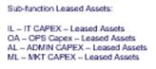](https://eu-prod.asyncgw.teams.microsoft.com/v1/objects/0-weu-d7-aa22cf042b4675189056d10b6d970bec/views/imgo)

When EM requests new Capex WBSs for new Leased Assets (**via e-flows request**), they **must use the new Sub-Functions**. These are relevant for both ACTUAL and Forecast process.

Master data changes are already in place in ECC (GMDM) and must now be used by EMs.

## MGMT Accounts – IFRS16

Since 2019, following Statutory changes regarding the implementation of IFRS16, we have aligned respectively Management reporting by updating the ND/CF rules and to create **7 BPC memo accounts for CF adjustments:**

* MEMO_OBA69710        CF adj. for IFRS16 - Leased Assets (Property)
* MEMO_OBA69720        CF adj. for IFRS16 - Leased Assets (P&E, Other)
* MEMO_OBA69760 CF adj. for IFRS16 - Accumulated Depreciation
* MEMO_OBA69700        CF adj. for IFRS16 - Net leased assets
* MEMO_OBA69800        CF adj. for IFRS16 - Lease Liabilities (within Borrowings)
* MEMO_OBA69054 CF adj IFRS16-(Gain)/loss arising from sale/leaseback trans
* MEMO_OBA69055 CF adj IFRS16- Confirm transaction value less the assets NBV

The CF rules related to finance leases (both capital and interest), as per instructions, will require an additional input as there is currently no data flowing from ECC that would enable an automatic calculation of the outflows.

In addition, I301 – Flow Reclassification and Additional Inputs for CF input form was updated with an extra sheet for the new memo accounts which will be used for IFRS16 reporting purposes going forward (only for actuals)

On top of that, there are some other changes in regards of IFRS16 reporting, these being related to the following updates:

1. --- even if initially it was communicated that a new P&L account will be created in order to capture the Gain/Loss from Disposal of Leased Assets, due to the changes which should have been made and the limited time, we’ll move on by using a new memo account – *MEMO_XX_POE4000 – (Gain)/Loss on Lease Modification and Reassessments*;

--- the net amount from this account will go to operating expenses in P&L, in the same time being added back in the CF rules as a non-cash item;

--- also, a new CEG was created to be used in OVH module – *XX_POE4000 – (Gain)/Loss on Lease Modification and Reassessments;*

--- as a note, the above CEG XX_POE4000 is linked to MEMO_XX_POE4000.

1. similar to *MBCL15300 Finance lease (curr) - interest accrued external*, a new BS account *MBNL14000 Finance Lease – Principal Interest External >1yr* was created as well – same CF/ND rules as per Finance Lease (curr) – interest accrued external account

**NOTE:**

As per CP&A Instructions, Capex WBS subfunction have been updated in ECC to accommodate the split between Leased Asset vs. Owned Asset (or genuine) as per IFRS16 requirements.

The Sub-Function is part of Capex WBS element naming convention which provides Capex breakdown, therefore **4 new Sub-Functions** will be available (see below), being designed for new Capex WBS elements related to **Leased Assets (IFRS16)**

When EM requests new Capex WBSs for new Leased Assets **(via e-flow request)**, **they must use the new Sub-Functions**. These are relevant both for Actual and Forecast process; master data changes are already in place in ECC (GMDM).

Except the above updates, there are no other changes in terms of IFRS16 reporting principles since 2019, therefore please see below the *IFRS16 instructions* for your reference.

